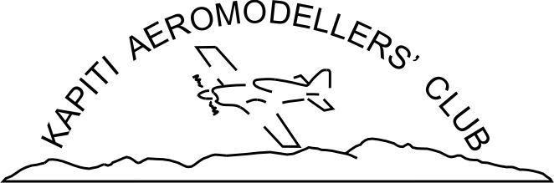 Aircraft Safety Inspection Form
(Club Members only)

The following pre-flight checks are what KAMC recommends when building or assembling an aircraft.

INSPECTION CHECK LIST:

GENERAL APPEARANCE and AIRFRAME:
Crash damage – Warps - Heat damage – Covering – Hatches - Canopy Secure ….……………………………….….

ENGINE and SYSTEMS:
Engine mount secure ………………………………………………………………………………………………………………………...….
Fuel system secure and no obvious leaks ………………………………………………………………………………….……………
Intake and/or exhaust secure ……………………………………………………………………………………………………..………….
Throttle servo Secure & arm screw fitted ………………….……………………………………………………………..…………….

DUCTED FAN:
Engine, Muffler, Fan Unit and Ducting Secure ……………………………………………………………………………………..….

WINGS:
Attachment Secure ………………………………………………………………………………………………………………………………….
Aileron/Flap Hinges Secure …………………………………………………………………………………………..…………………………
Control Horns Secure …………………………………………………………………………………………………………………………..….
Control Link Keepers Attached …………………………………………………………………………………………………………………
Servos Secure & arm screw fitted ………………………………………………………………………………………………………..….
Control Pushrod Stiffness ……………………………………………………………………………………………..……………………..….

TAILPLANE:
Attachment Secure ………………………………………………………………………………………………………………………………….
Aileron/Flap Hinges Secure ………………………………………………………………………………………………………………………
Control Horns Secure ……………………………………………………………………………………………………………………………….
Control Link Keepers Attached …………………………………………………………………………………………………………………
Servos Secure & arm screw fitted …………………………………………………………………………………………………………….
Control Pushrod Stiffness …………………………………………………………………………………………………..………………..….

LANDING GEAR:
Mounting Secure ………………………………………………………………………………………………………………………………..……
Steering Working …………………………………………………………………………………………………………………………………..…

PRE-FLIGHT CHECK:
Aileron/Flaps Direction OK ………………………………………………………………………………………………………….…………..
Elevator Direction OK ……………………………………………………………………………………………………………….……………..
Rudder Direction OK ………………………………………………………………………………………………………………….…………….
Throttle Direction OK …………………………………………………………………………………………………………………….…………

Authorised to fly in terms of MFNZ safety guidelines:

